EXPERIMENT-8
IMPLEMENTATION OF 3DES
AIM:
To implement Triple DES (3DES) encryption and decryption using three keys.
ALGORITHM
- Read the plaintext.
- Read three keys K1, K2, K3.
- Encrypt the plaintext using K1.
- Encrypt the result using K2.
- Encrypt the result using K3.
- Display the encrypted text in hexadecimal format.
- Decrypt using K3, then K2, then K1.
- Display the decrypted plaintext.
Encryption:
C = E(K3, E(K2, E(K1, P)))
Decryption:
P = D(K1, D(K2, D(K3, C)))
CODE:
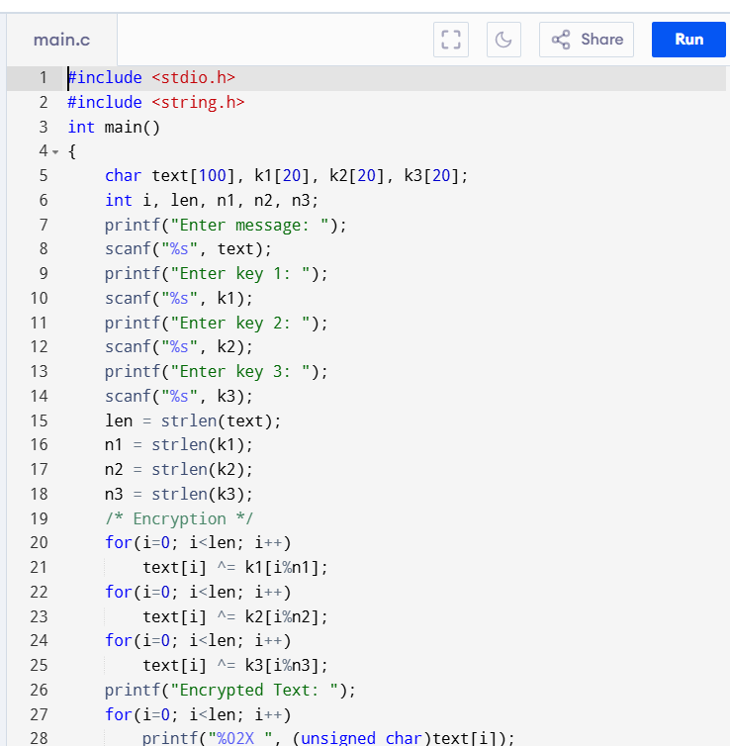
OUTPUT:
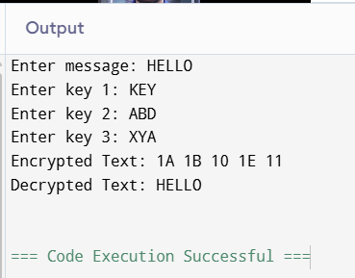
RESULT:
Thus, the Triple DES (3DES) encryption and decryption process was successfully demonstrated using three keys.

